 | CAR SERVICING  Technical Design Document
 | Prepared By / Last Updated By | Reviewed By | Approved By
Name | AMAN AKASH  VISHAL CHOUDARY  PHANI MAHESH  HIMMAT SINGH | MS. DEEPIKKAA S
Role | INTERNS | TECHNICAL TRAINER
Signature
Date | 14TH JULY, 2022

Table of Contents

1.0 Introduction 3
1.1 Purpose of this document 3
1.2 Project overview 3
2.0 Solution Summary 3
2.1 Scope 3
2.2 Assumptions 3
2.3 Dependencies 3
2.4 Risks 3
3.0 Schematic Diagram 3
4.0 System Design 4
4.1 Proposed design 4
4.2 Component inventory 4
5.0 Database Design 4
5.1 Data Model 4
5.2 Tables Structure 4
6.0 Appendices 4
6.1 Glossary 4
6.2 Other 5
7.0 Terms & Conditions 5
8.0 Change Log 5

Introduction

Purpose of this document
The purpose of this document is to document the technical design, component details and Database design. This will also capture the scope, assumptions, risk, dependencies of this project.

Project overview
The Objective is to prepare a web application, which automates the entire system of providing and availing Car Services, which improves the efficiency. It provides a friendly graphical user interface which proves to be way better when compared to the existing system of visiting each vendor manually and gives appropriate access to the authorized users depending on their permissions. It effectively overcomes the delay in communications and updating of information becomes so easy.

Solution Summary

Scope
The scope of this project is to make Online Car Service Management System for Car Company.This enables User to search for nearest service centers for their car online and also book a convenient slot just sitting at home.This enables various service centers to register online and get customers without spending unnecessary on advertisement.This software will eliminate manual documentation record keeping thus decreasing the overall time of process..

Assumptions
To use the application user needs to have a device with active internet connection.

Dependencies
- spring-boot-starter-tomcat
- jstl
- tomcat-embed-jasper
- spring-boot-starter-test
- mysql-connector-java
- spring-boot-devtools
- spring-boot-starter-web
- spring-boot-starter-validation
- spring-jdbc
- spring-boot-starter-data-jdbc

Risks
<This sub-section shall state the risks predicted for this project>

Schematic Diagram
A schematic, or schematic diagram, is a representation of the elements of a system using abstract, graphic symbols rather than realistic pictures. It gives an overview of overall system.
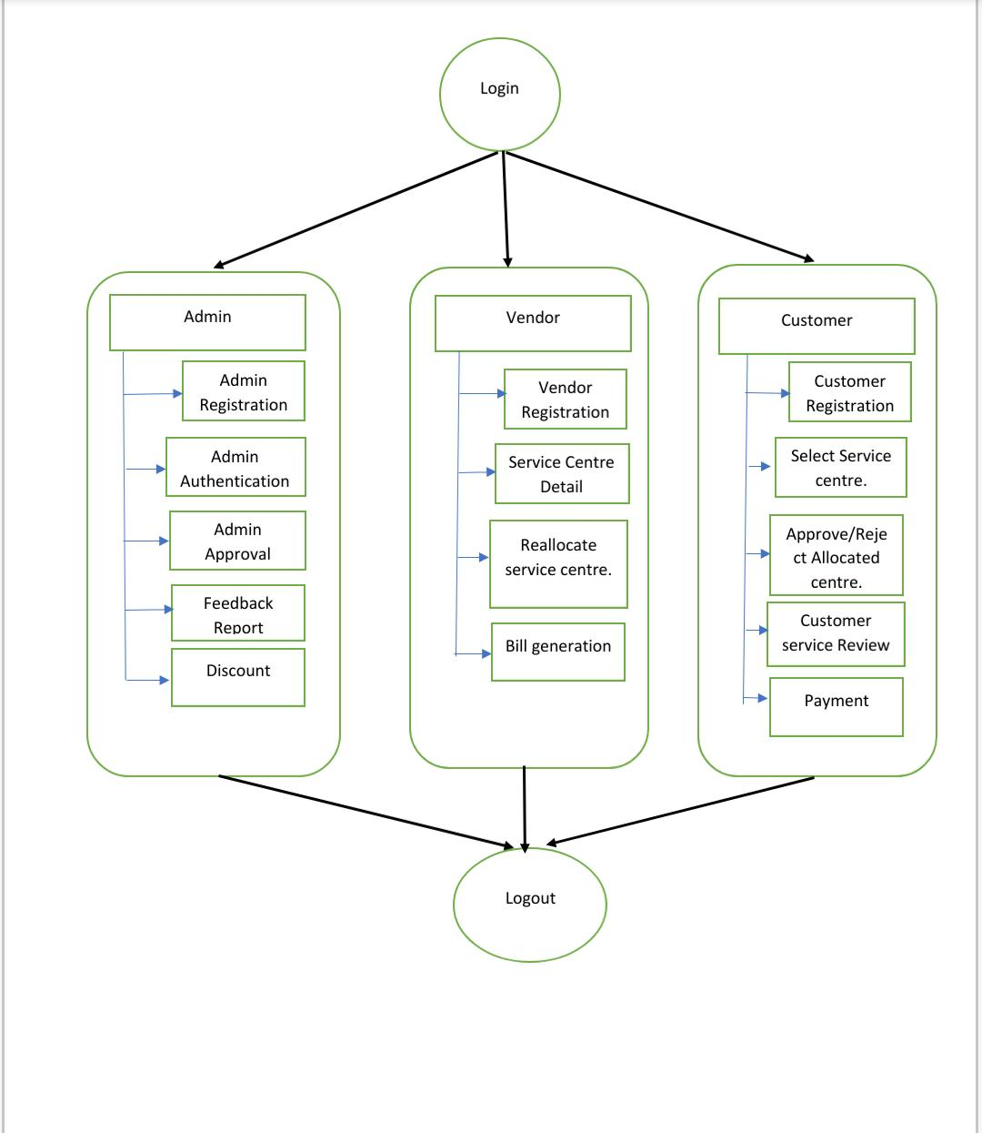

USE-CASE DIAGRAM :-
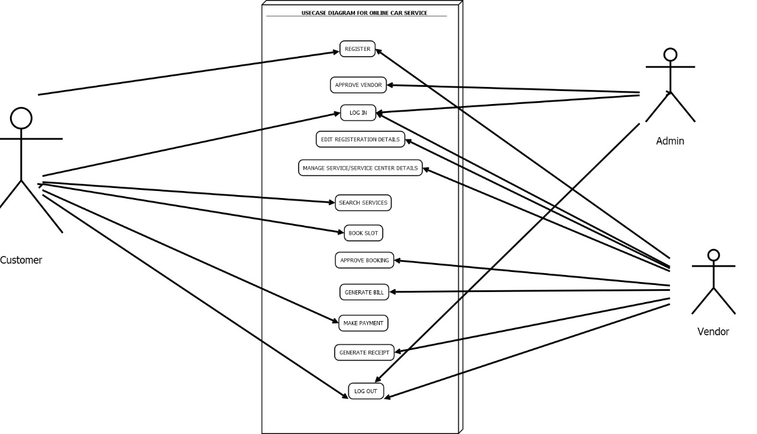

System Design

Proposed design
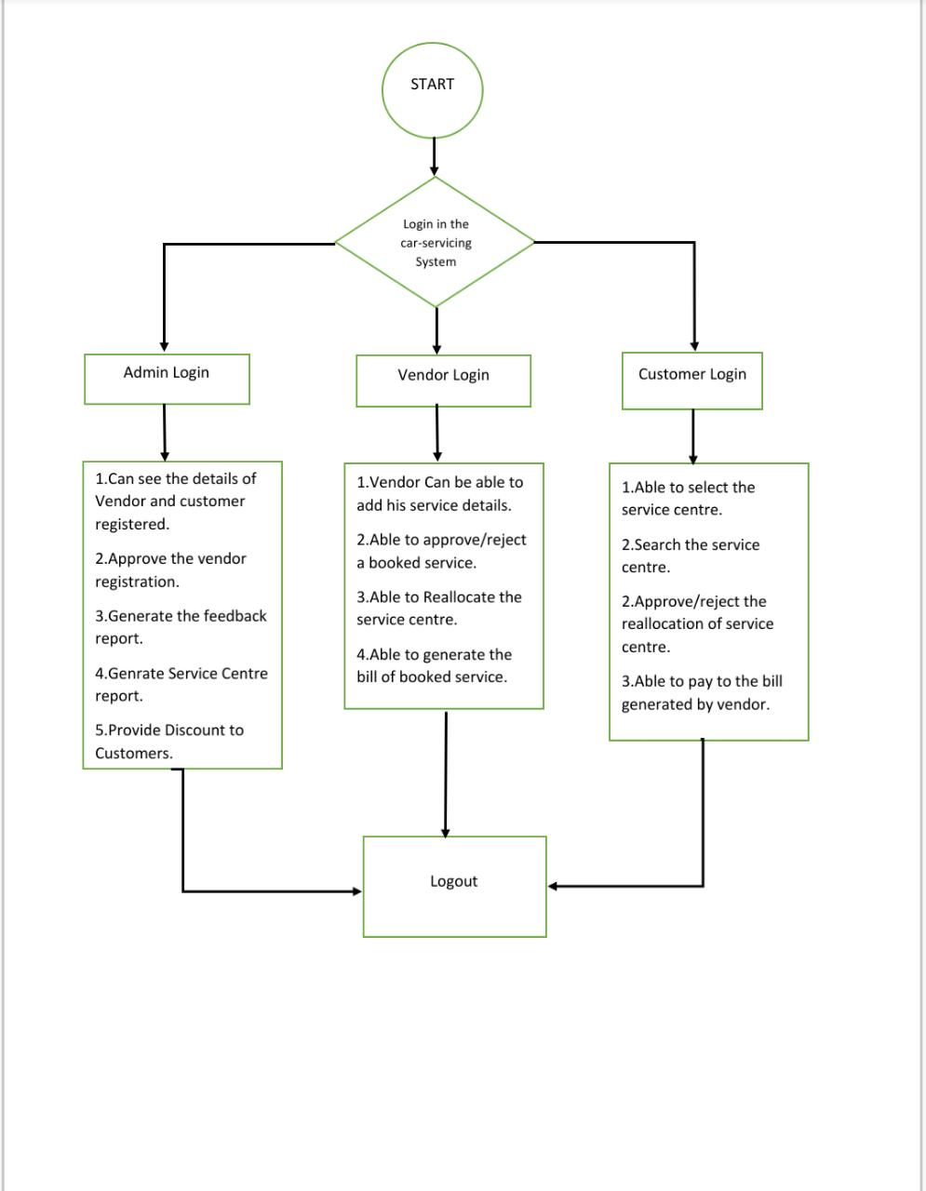
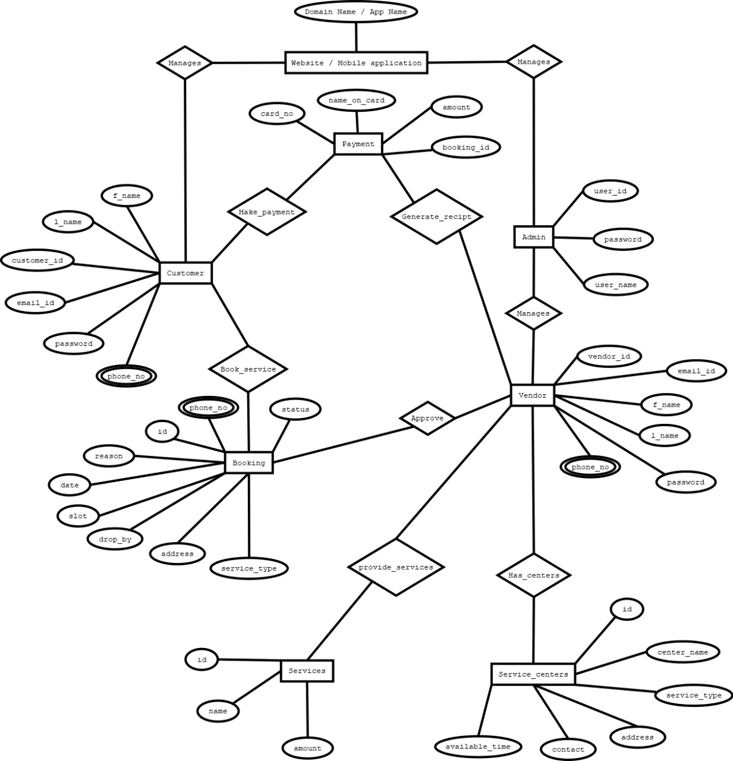

Component inventory
CID | Component | Type | Module | Description
C1 | AdminController | Controller | com.carservicing.controller | Controller layer for Admin
C2 | CustomerController | Controller | com.carservicing.controller | Controller layer for Customer
C3 | HomeController | Controller | com.carservicing.controller | Controller layer for Home
C4 | VendorController | Controller | com.carservicing.controller | Controller layer for Vendor
C5 | Admin | Model | com.carservicing.models | Model layer for Admin
C6 | Booking | Model | com.carservicing.models | Model layer for Booking
C7 | Customer | Model | com.carservicing.models | Model layer for Customer
C8 | Payment | Model | com.carservicing.models | Model layer for Payment
C9 | PaymentDTO | Model | com.carservicing.models | Model layer for Payment DTO
C10 | ServiceCenter | Model | com.carservicing.models | Model layer for Service Centre
C11 | ServiceItem | Model | com.carservicing.models | Model layer for Service Item
C12 | ServiceItemDTO | Model | com.carservicing.models | Model layer for Service Item DTO
C13 | Vendor | Model | com.carservicing.models | Model layer for Vendor
C14 | AdminRepository | Repository | com.carservicing.repos | Repository layer for Admin
C15 | BookingRepository | Repository | com.carservicing.repos | Repository layer for Booking
C16 | CustomerRepository | Repository | com.carservicing.repos | Repository layer for Customer
C17 | PaymentRepository | Repository | com.carservicing.repos | Repository layer for Payment
C18 | ServiceCentreRepository | Repository | com.carservicing.repos | Repository layer for Service Centre
C19 | ServiceItemRepository | Repository | com.carservicing.repos | Repository layer for Service Item
C20 | VendorRepository | Repository | com.carservicing.repos | Repository layer for Vendor
C21 | AdminService | Service | com.carservicing.services | Service layer for Admin
C22 | BookingService | Service | com.carservicing.services | Service layer for Booking
C23 | CustomerService | Service | com.carservicing.services | Service layer for Customer
C24 | ServiceCenterService | Service | com.carservicing.services | Service layer for Service Center
C25 | VendorService | Service | com.carservicing.services | Service layer for Vendor

Database Design

Tables Structure

Admin Table
Column Name | Data Type | Length | Nulls | Key | Default
userid | varchar | 30 | NO | PRI | NULL
uname | varchar | 30 | NO |  | NULL
pwd | varchar | 30 | NO |  | NULL

Booking Table
Column Name | Data Type | Length | Nulls | Key | Default
Id | Int |  | NO | PRI | NULL
Date | Date |  | NO |  | NULL
Slot | varchar |  | NO |  | NULL
Phone | varchar | 10 | NO |  | NULL
serviceType | varchar |  | NO |  | NULL
Bookdate | Date |  | NO |  | NULL
Status | varchar |  | NO |  | NULL
reason | varchar |  | NO |  | NULL
dropby | varchar |  | NO |  | NULL

Customer Table
Column Name | Data Type | Length | Nulls | Key | Default
id | int |  | NO | PRI | NULL
First_name | Varchar | 30 | NO |  | NULL
Last_name | Varchar | 30 | NO |  | NULL
Email | Varchar | 50 | NO |  | NULL
Phone | Int | 10 | NO |  | NULL
Password | varchar | 20 | NO |  | NULL

Service Center table
Column Name | Data Type | Length | Nulls | Key | Default
id | Int |  | NO | PRI | NULL
centerName | varchar |  | NO |  | NULL
serviceType | varchar |  | NO |  | NULL
Address | varchar |  | NO |  | NULL
Contact | varchar |  | NO |  | NULL
AvailableTime | varchar |  | NO |  | NULL

Vendor table
Column Name | Data Type | Length | Nulls | Key | Default
Id | Int |  | NO | PRI | NULL
First _name | Varchar | 30 | NO |  | NULL
Last _name | Varchar | 30 | NO |  | NULL
Email | Varchar |  | NO |  | NULL
Phone | Varchar | 10 | NO |  | NULL
Pwd | Varchar | 20 | NO |  | NULL
active | bit | 1 | NO |  | ‘\0’

Serviceitem
Column Name | Data Type | Length | Nulls | Key | Default
Id | Int |  | NO | PRI | NULL
Name | varchar | 30 | NO |  | NULL
amount | double |  | NO |  | NULL

Payment table
Column Name | Data Type | Length | Nulls | Key | Default
Id | Int |  | NO | PRI | NULL
Cardno | Varchar | 16 | NO |  | NO
Nameoncard | Varchar |  | NO |  | NO
Amount | double |  | NO |  | NO
Booking |  |  | NO |  | NO
paydate | date |  | NO |  | NO

Appendices

Glossary
Acronyms | Definitions

Images of the Project
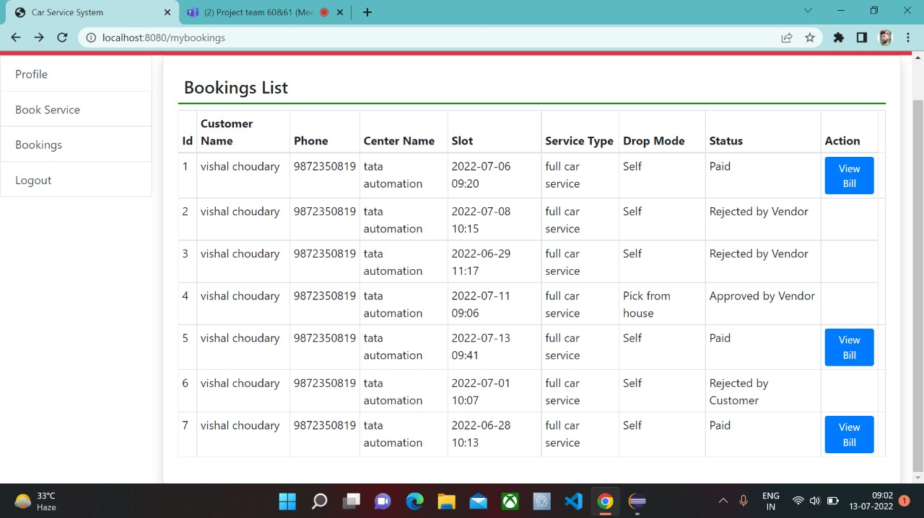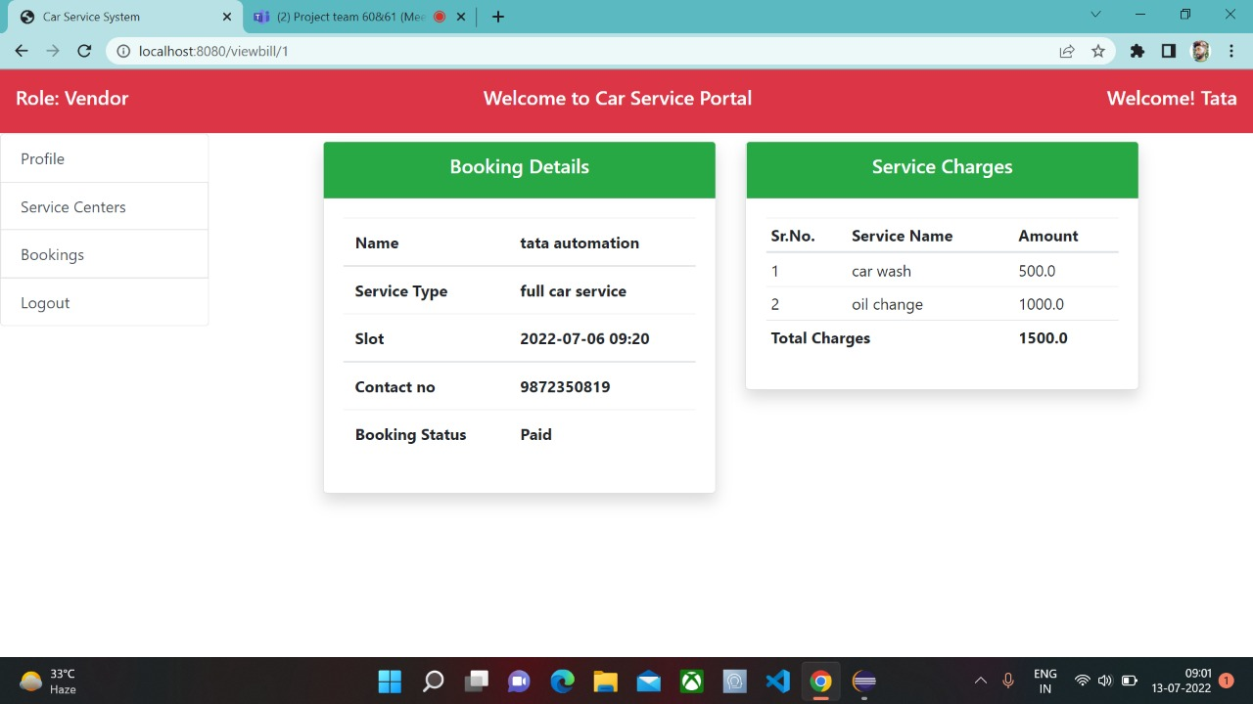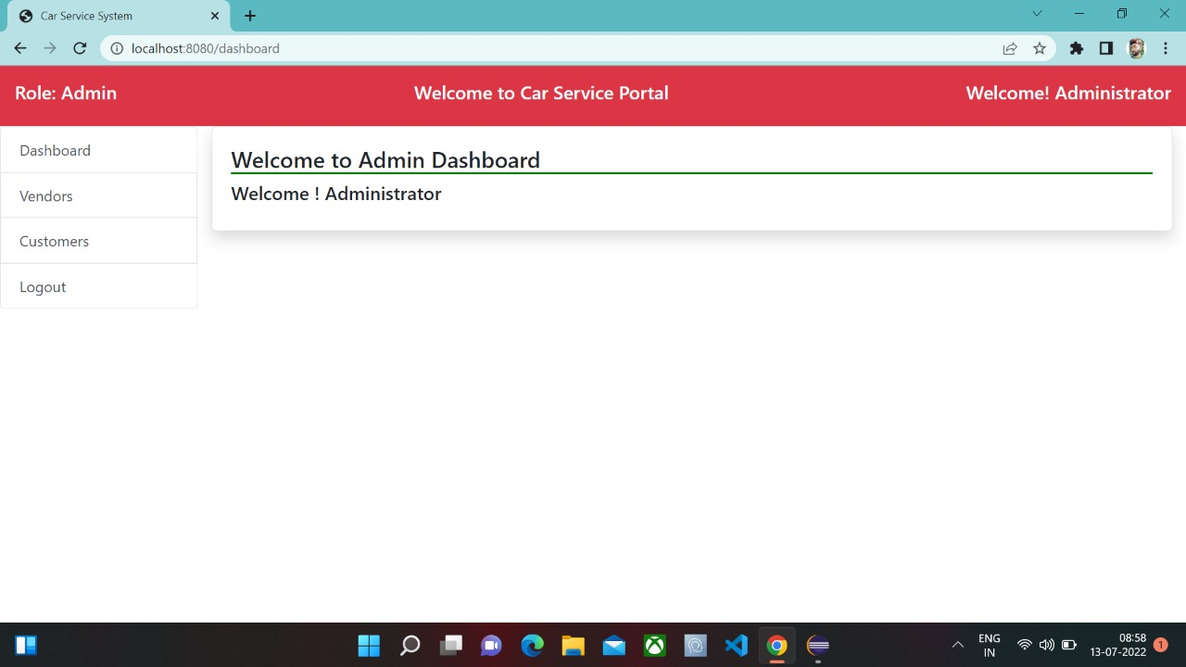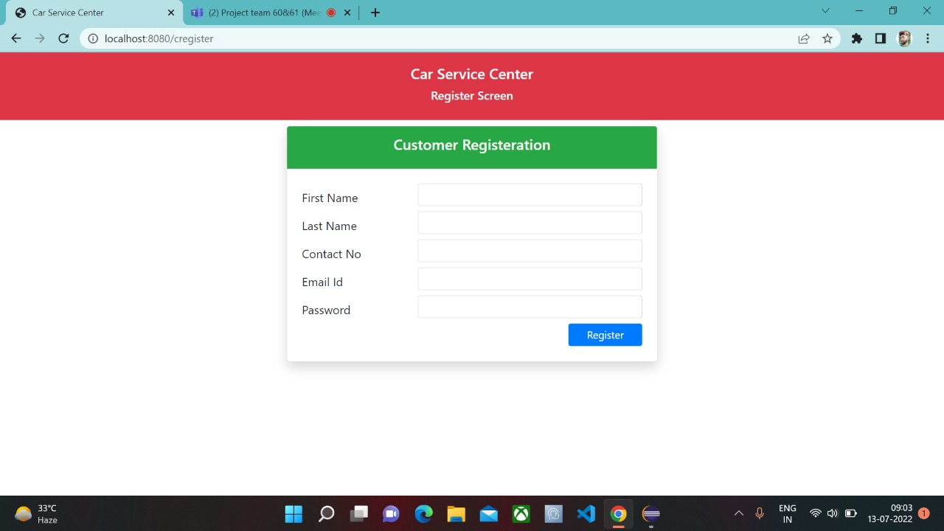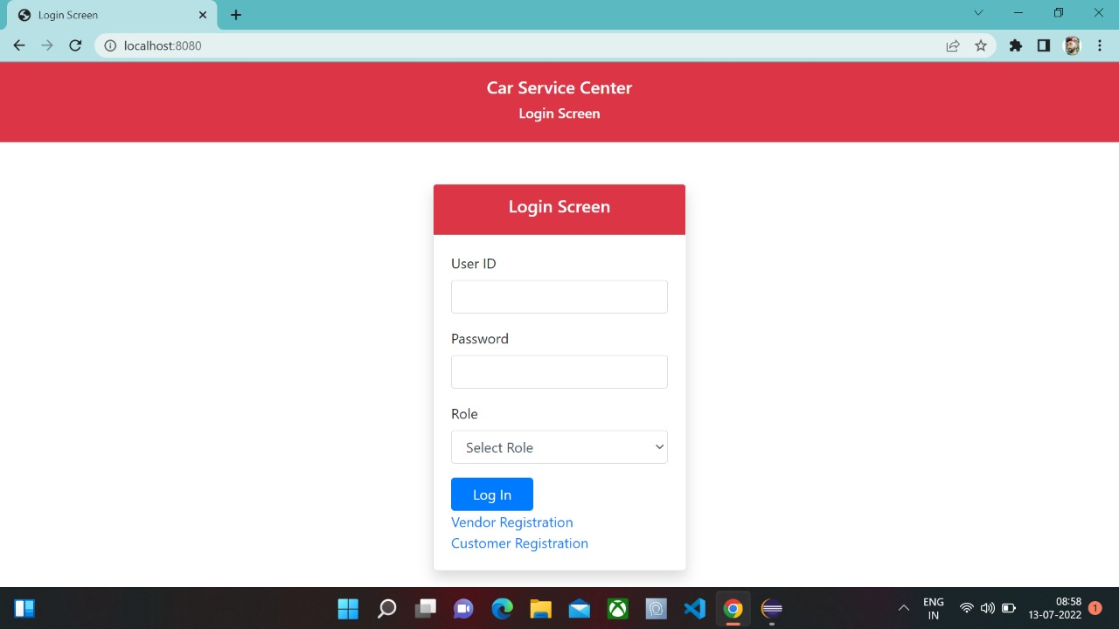

Terms & Conditions
Disclaimer: Please do not circulate or distribute this document outside of Cognizant Network, We have a Zero Tolerance Policy. Kindly adhere to 100% Compliance at all times.

Change Log
Please note that this table needs to be maintained even if a Configuration Management tool is used.
Version Number | Changes made
V<n.n> | <If the change details are not explicitly documented in the table below, reference should be provided here>
V<n.n> | Page no | Changed by | Effective date | Changes effected

